

**Student Name: Mayda Muhammad Anwer**

**Id: BAI-23S-046**

**Year: 2023**

**Semester: 2nd**

**Section: 1st**

**Spring/Fall: Fall**

**Program code:**

**Course Teacher: Miss Aqsa Umer**

**Table Creation Queries Related To Project:**

(i)Create a new table for patient details:

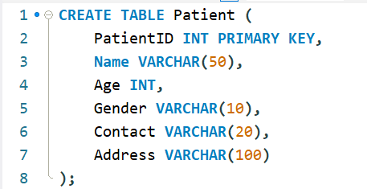

(ii)Add a table for doctor information:

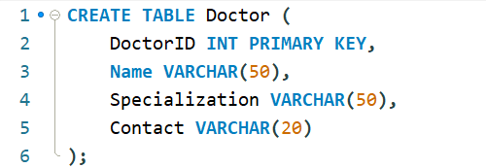

Table Insertion Queries Related To Project:

(iii)Insert a new patient record:



(iv)Add a doctor's information:



(v)Add a new column to the Patient table:



(vi)Modify Doctor table column data type:



(vii)Add a Foreign Key constraint to link tables:



(viii)Create a Check constraint for Age in Patient table:



(ix)Perform an Inner Join between Patient and Doctor tables:

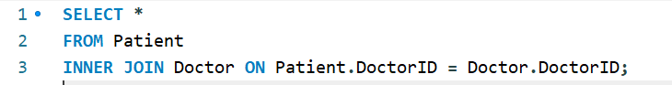

(x)Retrieve patient details with associated records using LEFT JOIN:

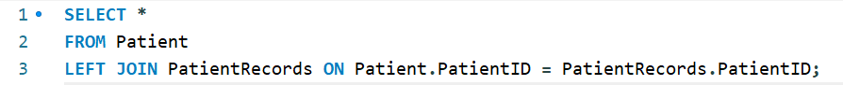

(xi)Calculate the average age of patients:



(xii)Count the number of patients:



(xiii)Retrieve patients with specific doctors:



(xiv)Find patients with no records:

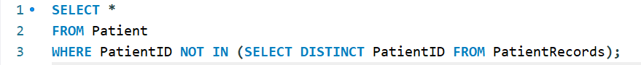

(xv) IN Operator Query: Retrieve patients with specific IDs:

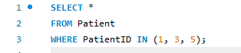

(xvi) NOT IN Operator Queries: Fetch patients not in a certain age group:

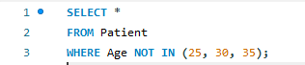

(xvii)LIKE Operator Queries: Find patients with names starting with 'A':

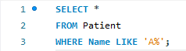

(xviii) ORDER BY Queries: Retrieve patients sorted by age in descending order:

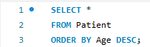

(xix) SUM Function Query: Calculate the total of patient ages:



(xx)COUNT Function Query: Count the number of female patients:

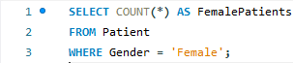

(xxi) GRANT Query (Database Permissions): Grant SELECT permission to a user on a specific table:



(xxii) REVOKE Query (Database Permissions): Revoke UPDATE permission from a user on a specific table:



(xxiii) JOIN Queries: Perform a LEFT JOIN between Patient and Doctor tables:

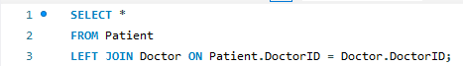

(xxiv) UNION Query: Combine results of two SELECT queries:

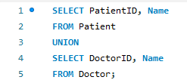

(xxv) MAX Function Query: Find the oldest patient's age:



(xxvi) MIN Function Query: Retrieve the youngest patient's age:



(xxvii) DISTINCT Query: Fetch unique genders among patients:



(xxviii) GROUP BY Query: Count patients per doctor:

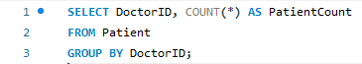

(xxix) UPDATE Query: Change the contact number for a specific patient:

